**Full Stack Development with MERN**

**Frontend Development Report**

|  |  |
| --- | --- |
| Date | 15th July 2024 |
| Team ID | SWTID1720019632 |
| Project Name | HOUSE RENT APP USING MERN |
| Maximum Marks |  |

**Project Title: HOUSE RENT APP USING MERN**

Date: [20/07/2024]

Prepared by: [Madhavv Viswanath. K]

**Objective**

The objective of this report is to document the frontend development progress and key aspects of the user interface implementation for the HOUSE RENT APP USING MERN project.

**Technologies Used**

* **Frontend Framework:** React.js
* **State Management:** Context API
* **UI Framework/Libraries:** Tailwind CSS
* **API Libraries:** Axios

**Project Structure**

* **The assets** Folder contains all the necessary images for the application.
* **Modules** contains all the necessary pages with appropriate folders
* **Vite.config.js** this makes the react app faster to load than native webpack bundler.
* **node modules** contain all the required dependencies for the frontend.

**Key Components**

1. **App.js**
   * Responsible for routing and main application layout.

1. **/Components**
   * Contains reusable UI components used across the application.
   * **Header Component**

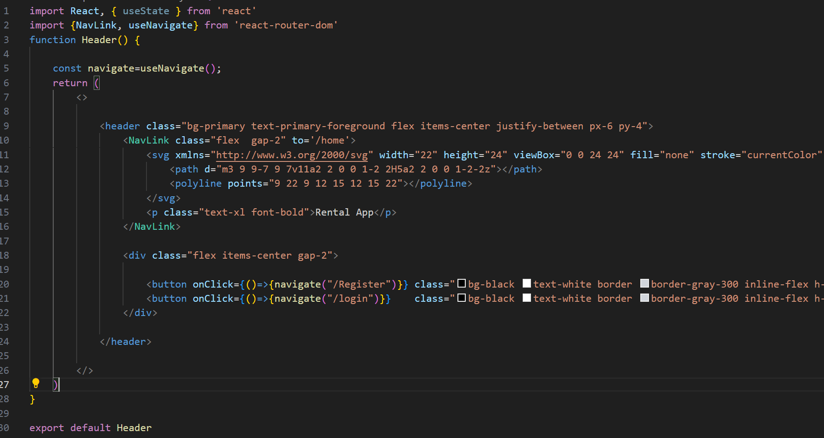

* + **Footer Component**

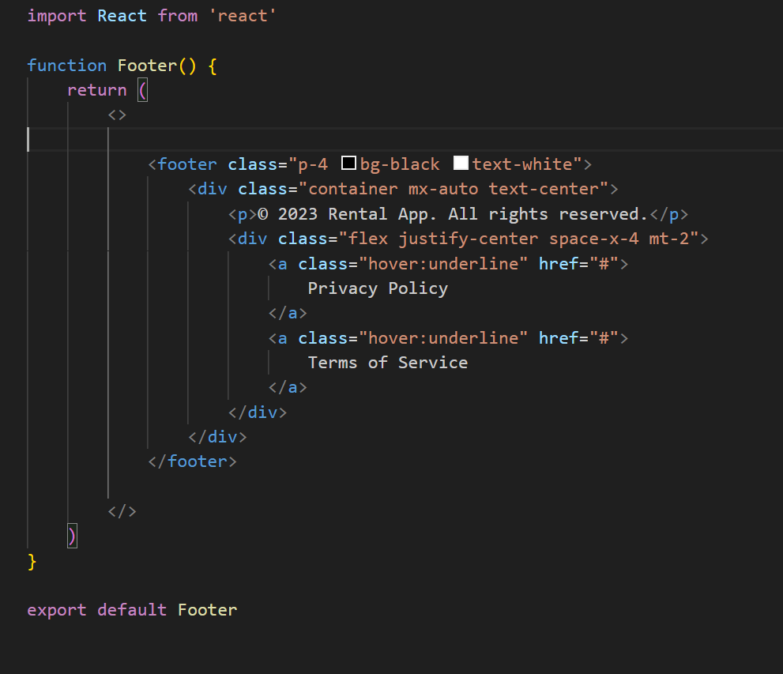

1. **/Pages**
   * Includes different pages for Web App.
   * **Common Folder**
     1. **Contains About Us, Login, Register, Home pages**
2. function AboutUs() {
3. return (
4. <>
5. <div class="flex flex-col min-h-screen">
6. <main class="flex-1 p-8">
7. <div class="max-w-4xl mx-auto space-y-8">
8. <div>
9. <h1 class="text-4xl font-bold">About Us</h1>
10. <p class="text-lg text-muted-foreground mt-4">
11. Rental App is a leading platform that connects renters with the perfect properties. Our mission is to
12. simplify the rental process and provide a seamless experience for both landlords and tenants.
13. </p>
14. </div>
15. <div>
16. <h2 class="text-2xl font-bold">Our Story</h2>
17. <p class="text-lg text-muted-foreground mt-4">
18. Rental App was founded in 2024 by a team of passionate Web Dev enthusiasts who saw the need for a more
19. efficient and user-friendly rental platform. We started with a simple goal: to make the rental process
20. easier and more accessible for everyone.
21. </p>
22. <p class="text-lg text-muted-foreground mt-4">
23. Over the years, we've grown to become one of the most trusted rental platforms in the industry. Our team
24. of experts works tirelessly to curate a diverse selection of properties and provide exceptional customer
25. service to our users.
26. </p>
27. </div>
28. <div>
29. <h2 class="text-2xl font-bold">Our Values</h2>
30. <ul class="text-lg text-muted-foreground mt-4 space-y-2">
31. <li>
32. <span class="font-bold">Transparency:</span> We believe in being upfront and honest with our users,
33. providing clear and accurate information about our properties and services.
34. </li>
35. <li>
36. <span class="font-bold">Accessibility:</span> Our platform is designed to be user-friendly and
37. accessible to everyone, regardless of their technical expertise or background.
38. </li>
39. <li>
40. <span class="font-bold">Innovation:</span> We are constantly exploring new ways to improve the rental
41. experience, leveraging the latest technologies and industry insights to stay ahead of the curve.
42. </li>
43. <li>
44. <span class="font-bold">Community:</span> We are committed to building a strong and supportive community
45. of renters and landlords, fostering connections and collaboration.
46. </li>
47. </ul>
48. </div>
49. <div>
50. <h2 class="text-2xl font-bold">Our Team</h2>
51. <div class="grid grid-cols-1 sm:grid-cols-2 md:grid-cols-3 gap-8 mt-4">
52. <div class="bg-muted rounded-lg p-4 shadow-lg">
53. <img src={""} alt="John Doe" class="rounded-full w-24 h-24 mx-auto" />
54. <h3 class="text-xl font-bold mt-4">John Doe</h3>
55. <p class="text-muted-foreground">Co-Founder and CEO</p>
56. </div>
57. <div class="bg-muted rounded-lg p-4 shadow-lg">
58. <img src={"" } alt="Jane Smith" class="rounded-full w-24 h-24 mx-auto" />
59. <h3 class="text-xl font-bold mt-4">Jane Smith</h3>
60. <p class="text-muted-foreground">Co-Founder and CTO</p>
61. </div>
62. <div class="bg-muted rounded-lg p-4 shadow-lg">
63. <img src={ ""} alt="Michael Johnson" class="rounded-full w-24 h-24 mx-auto" />
64. <h3 class="text-xl font-bold mt-4">Michael Johnson</h3>
65. <p class="text-muted-foreground">Head of Operations</p>
66. </div>
67. </div>
68. </div>
69. </div>
70. </main>
71. </div>
72. </>
73. )
74. }
75. function Home() {
76. const navigate=useNavigate()
77. return (
78. <>
79. <div class="flex min-h-[100dvh] flex-col">
80. <main class="flex-1">
81. <section class="bg-primary text-primary-foreground py-12 md:py-20 lg:py-28">
82. <div class="container mx-auto px-4 md:px-6 lg:px-8">
83. <div class="grid items-center gap-8 md:grid-cols-2">
84. <div>
85. <h1 class="mb-4 text-4xl font-bold md:text-5xl lg:text-6xl">Find Your Perfect Rental</h1>
86. <p class="mb-8 text-lg md:text-xl">Our rental app makes it easy to discover and book the ideal property for your needs.</p>
87. <button onClick={()=>{navigate('/About')}}  class="bg-black text-white border border-gray-300 inline-flex h-10 items-center justify-center whitespace-nowrap rounded-md px-5 text-sm font-medium transition-transform  focus:outline-none focus:ring-2 focus:ring-white focus:ring-offset-2 hover:bg-blue-600 hover:text-white hover:scale-105 hover:shadow-lg disabled:pointer-events-none disabled:opacity-50">About Us</button>
88. </div>
89. <div>
90. <img src='assets/Profile.jpg' alt="Hero Image" class="rounded-xl" />
91. </div>
92. </div>
93. </div>
94. </section>
95. </main>
97. </div>
98. </>
99. )
100. }
101. export default Home
102. function Login() {
103. const [email, setEmail] = useState();
104. const [password, setpassword] = useState();
105. const [user_type, setUser_type]=useState();
106. const navigate=useNavigate();
107. const handleSubmit = (e) => {
108. e.preventDefault();
109. axios.post('http://localhost:3001/login', {email, password,user_type})
110. .then(result => {
111. console.log(result)
112. if(result.data==="Success")
113. {
114. if(user_type==="Renter")
115. {
116. navigate('/details')
117. }
118. else
119. {
120. navigate('/owner')
121. }
122. }
123. else
124. {
125. if(result.data==="The password or Usertype is incorrect")
126. {
127. alert(result.data);
128. }
129. if(result.data==="Not Registered")
130. {
131. alert(result.data);
132. }
133. }
134. })
136. .catch(err => console.log(err))
137. }
138. return (
139. <>
140. <div class="flex min-h-[100vh] flex-col">
141. <main class="flex-1">
142. <section class="w-full py-12 ">
143. <div class="container px-6 md:px-24">
144. <div class="grid gap-6 lg:grid-cols-[1fr_500px] lg:gap-12 xl:grid-cols-[1fr_550px]">
145. <div class="flex flex-col justify-center space-y-3">
146. <div class="space-y-2">
147. <h1 class="text-3xl font-bold tracking-tighter sm:text-5xl xl:text-6xl/none">Login to Your Account</h1>
148. <p class="text-muted-foreground max-w-[600px] md:text-xl">Welcome</p>
149. </div>
150. <form onSubmit={handleSubmit}>
151. <div class="bg-card text-card-foreground w-full max-w-md rounded-lg border shadow-sm" data-v0-t="card">
152. <div class="flex flex-col space-y-1 p-6">
153. <h3 class="whitespace-nowrap text-2xl font-semibold tracking-tight">Login</h3>
154. </div>
155. <div class="relative h-10 w-72 min-w-[200px] ml-6">
156. <select name='user-type' id='user-type' onChange={(e) => setUser_type(e.target.value)}
157. class="peer h-full w-full rounded-[7px] border border-blue-gray-200 border-t-transparent bg-transparent px-3 py-2.5 font-sans text-sm font-normal text-blue-gray-700 outline outline-0 transition-all placeholder-shown:border placeholder-shown:border-blue-gray-200 placeholder-shown:border-t-blue-gray-200 empty:!bg-gray-900 focus:border-2 focus:border-gray-900 focus:border-t-transparent focus:outline-0 disabled:border-0 disabled:bg-blue-gray-50">
158. <option value="Owner">Owner</option>
159. <option value="Renter">Renter</option>
161. </select>
162. <label
163. class="before:content[' '] after:content[' '] pointer-events-none absolute left-0 -top-1.5 flex h-full w-full select-none text-[11px] font-normal leading-tight text-blue-gray-400 transition-all before:pointer-events-none before:mt-[6.5px] before:mr-1 before:box-border before:block before:h-1.5 before:w-2.5 before:rounded-tl-md before:border-t before:border-l before:border-blue-gray-200 before:transition-all after:pointer-events-none after:mt-[6.5px] after:ml-1 after:box-border after:block after:h-1.5 after:w-2.5 after:flex-grow after:rounded-tr-md after:border-t after:border-r after:border-blue-gray-200 after:transition-all peer-placeholder-shown:text-sm peer-placeholder-shown:leading-[3.75] peer-placeholder-shown:text-blue-gray-500 peer-placeholder-shown:before:border-transparent peer-placeholder-shown:after:border-transparent peer-focus:text-[11px] peer-focus:leading-tight peer-focus:text-gray-900 peer-focus:before:border-t-2 peer-focus:before:border-l-2 peer-focus:before:border-gray-900 peer-focus:after:border-t-2 peer-focus:after:border-r-2 peer-focus:after:border-gray-900 peer-disabled:text-transparent peer-disabled:before:border-transparent peer-disabled:after:border-transparent peer-disabled:peer-placeholder-shown:text-blue-gray-500">
164. Select a User Type
165. </label>
166. </div>
167. <div class="grid gap-4 p-6">
168. <div class="grid gap-2">
169. <label for="email" class="text-sm font-medium leading-none peer-disabled:cursor-not-allowed peer-disabled:opacity-70" > Email </label>
170. <input  name="email" id="email" placeholder="john@example.com" type="email" onChange={(e) => setEmail(e.target.value)} class="border-input bg-background ring-offset-background placeholder:text-muted-foreground focus-visible:ring-ring flex h-10 w-full rounded-md border px-3 py-2 text-sm file:border-0 file:bg-transparent file:text-sm file:font-medium focus-visible:outline-none focus-visible:ring-2 focus-visible:ring-offset-2 disabled:cursor-not-allowed disabled:opacity-50"  required />
171. </div>
172. <div class="grid gap-2">
173. <label for="password" class="text-sm font-medium leading-none peer-disabled:cursor-not-allowed peer-disabled:opacity-70" > Password </label>
174. <input name="password"  id="password" type="password" onChange={(e) => setpassword(e.target.value)} class="border-input bg-background ring-offset-background placeholder:text-muted-foreground focus-visible:ring-ring flex h-10 w-full rounded-md border px-3 py-2 text-sm file:border-0 file:bg-transparent file:text-sm file:font-medium focus-visible:outline-none focus-visible:ring-2 focus-visible:ring-offset-2 disabled:cursor-not-allowed disabled:opacity-50"  required />
175. </div>
176. </div>
177. <div class="flex items-center p-6">
178. <button class="align-middle select-none font-sans font-bold text-center uppercase transition-all disabled:opacity-50 disabled:shadow-none disabled:pointer-events-none text-xs py-3 px-6 rounded-lg bg-gray-900 text-white shadow-md shadow-gray-900/10 hover:shadow-lg hover:shadow-gray-900/20 focus:opacity-[0.85] focus:shadow-none active:opacity-[0.85] active:shadow-none block w-full"
179. type="submit">Sign In</button>
180. </div>
181. <div class="flex p-6 justify-items-center" >
182. <p class="pr-4">Not Registered?
183. <span class=" font-medium text-blue-600 dark:text-blue-500 hover:underline"> <NavLink to={'/register'} >Register</NavLink></span>
184. </p>
185. </div>
186. </div>
187. </form>
188. </div>
189. <div class="flex flex-col justify-center space-y-4">
190. <img src="https://images.unsplash.com/photo-1600585154340-be6161a56a0c?q=80&w=2670&auto=format&fit=crop&ixlib=rb-4.0.3&ixid=M3wxMjA3fDB8MHxwaG90by1wYWdlfHx8fGVufDB8fHx8fA%3D%3D" class="mx-auto aspect-video overflow-hidden rounded-xl object-cover object-center sm:w-full lg:order-last " />
191. </div>
192. </div>
193. </div>
194. </section>
195. </main>
196. </div>
197. </>
198. )
199. }
200. export default Login
201. function Register() {
202. const [name, setName] = useState();
203. const [phone, setPhone] = useState();
204. const [email, setEmail] = useState();
205. const [password, setpassword] = useState();
206. const [user_type, setUser_type]=useState();
207. const navigate = useNavigate();
208. const handleSubmit = (e) => {
209. e.preventDefault();
210. axios.post('http://localhost:3001/register', { name,user_type,phone, email, password })
211. .then(result => {console.log(result)
212. navigate('/login')})
213. .catch(err => console.log(err))
214. }
215. return (
216. <>
217. <div class="bg-card text-card-foreground mx-auto w-full  rounded-lg border shadow-sm max-w-screen-lg mt-16">
218. <div class="flex flex-col space-y-1.5 p-6">
219. <h3 class="whitespace-nowrap text-2xl font-semibold tracking-tight">Register for House Rental</h3>
220. <p class="text-muted-foreground text-sm">Sign up to start renting your dream home.</p>
221. </div>
222. <div class="p-6">
223. <form class="grid gap-4" onSubmit={handleSubmit}>
224. <div class="grid grid-cols-2 gap-4">
225. <div class="space-y-2">
226. <label for="name" class="text-sm font-medium leading-none peer-disabled:cursor-not-allowed peer-disabled:opacity-70" > Full Name </label>
227. <input name='name' id="name" placeholder="John Doe"  type='text'    onChange={(e) => setName(e.target.value)} class="border-input bg-background ring-offset-background placeholder:text-muted-foreground focus-visible:ring-ring flex h-10 w-full rounded-md border px-3 py-2 text-sm file:border-0 file:bg-transparent file:text-sm file:font-medium focus-visible:outline-none focus-visible:ring-2 focus-visible:ring-offset-2 disabled:cursor-not-allowed disabled:opacity-50"  required />
228. </div>
229. <div class="space-y-2">
230. <label for="phone" class="text-sm font-medium leading-none peer-disabled:cursor-not-allowed peer-disabled:opacity-70" > Phone Number </label>
231. <input name='phone' id="phone" placeholder="+1 (555) 555-5555" type="tel" onChange={(e) => setPhone(e.target.value)} class="border-input bg-background ring-offset-background placeholder:text-muted-foreground focus-visible:ring-ring flex h-10 w-full rounded-md border px-3 py-2 text-sm file:border-0 file:bg-transparent file:text-sm file:font-medium focus-visible:outline-none focus-visible:ring-2 focus-visible:ring-offset-2 disabled:cursor-not-allowed disabled:opacity-50"  required />
232. </div>
233. </div>
234. <div class="relative h-10 w-full ">
235. <select name='user-type' id='user-type' onChange={(e) => setUser_type(e.target.value)}
236. class="peer h-full w-full rounded-[7px] border border-blue-gray-200 border-t-transparent bg-transparent px-3 py-2.5 font-sans text-sm font-normal text-blue-gray-700 outline outline-0 transition-all placeholder-shown:border placeholder-shown:border-blue-gray-200 placeholder-shown:border-t-blue-gray-200 empty:!bg-gray-900 focus:border-2 focus:border-gray-900 focus:border-t-transparent focus:outline-0 disabled:border-0 disabled:bg-blue-gray-50">
237. <option value="Owner">Owner</option>
238. <option value="Renter">Renter</option>
239. </select>
240. <label for="user-type"
241. class="before:content[' '] after:content[' '] pointer-events-none absolute left-0 -top-1.5 flex h-full w-full select-none text-[11px] font-normal leading-tight text-blue-gray-400 transition-all before:pointer-events-none before:mt-[6.5px] before:mr-1 before:box-border before:block before:h-1.5 before:w-2.5 before:rounded-tl-md before:border-t before:border-l before:border-blue-gray-200 before:transition-all after:pointer-events-none after:mt-[6.5px] after:ml-1 after:box-border after:block after:h-1.5 after:w-2.5 after:flex-grow after:rounded-tr-md after:border-t after:border-r after:border-blue-gray-200 after:transition-all peer-placeholder-shown:text-sm peer-placeholder-shown:leading-[3.75] peer-placeholder-shown:text-blue-gray-500 peer-placeholder-shown:before:border-transparent peer-placeholder-shown:after:border-transparent peer-focus:text-[11px] peer-focus:leading-tight peer-focus:text-gray-900 peer-focus:before:border-t-2 peer-focus:before:border-l-2 peer-focus:before:border-gray-900 peer-focus:after:border-t-2 peer-focus:after:border-r-2 peer-focus:after:border-gray-900 peer-disabled:text-transparent peer-disabled:before:border-transparent peer-disabled:after:border-transparent peer-disabled:peer-placeholder-shown:text-blue-gray-500">
242. Select a User Type
243. </label>
244. </div>
245. <div class="space-y-2">
246. <label for="email" class="text-sm font-medium leading-none peer-disabled:cursor-not-allowed peer-disabled:opacity-70" > Email Address </label>
247. <input name="email" id="email" placeholder="john@example.com" type="email" onChange={(e) => setEmail(e.target.value)} class="border-input bg-background ring-offset-background placeholder:text-muted-foreground focus-visible:ring-ring flex h-10 w-full rounded-md border px-3 py-2 text-sm file:border-0 file:bg-transparent file:text-sm file:font-medium focus-visible:outline-none focus-visible:ring-2 focus-visible:ring-offset-2 disabled:cursor-not-allowed disabled:opacity-50"  required />
248. </div>
249. <div class="space-y-2">
250. <label  for="password" class="text-sm font-medium leading-none peer-disabled:cursor-not-allowed peer-disabled:opacity-70"> Password </label>
251. <input name="password"  id="password" type="password" onChange={(e) => setpassword(e.target.value)} class="border-input bg-background ring-offset-background placeholder:text-muted-foreground focus-visible:ring-ring flex h-10 w-full rounded-md border px-3 py-2 text-sm file:border-0 file:bg-transparent file:text-sm file:font-medium focus-visible:outline-none focus-visible:ring-2 focus-visible:ring-offset-2 disabled:cursor-not-allowed disabled:opacity-50"  required />
252. </div>
253. <div class="flex items-center p-6">
254. <button  type="submit"  class="block w-full select-none rounded-lg bg-gray-900 px-6 py-3 text-center align-middle font-sans text-xs font-bold uppercase text-white shadow-md shadow-gray-900/10 transition-all hover:shadow-lg hover:shadow-gray-900/20 focus:opacity-[0.85] focus:shadow-none active:opacity-[0.85] active:shadow-none disabled:pointer-events-none disabled:opacity-50 disabled:shadow-none"  >Register</button>
255. </div>
256. </form>
257. </div>
258. </div>
259. </>
260. )
261. }
262. export default Register

* **User Folder**

1. **Owner**
2. **Renter**

**Routing**

Routing is managed using React Router. Here are the main routes:

* **/home -** Routes to home page
* **/login** - Routes to Login page
* **/about**-Routes to About page
* **/register**-Routes to Register page
* **/details**-Routes to all the property cards page
* **/owner**-Routes to Add Property page
* **/prp/:id-**Routes to each individual page of the property

**Integration with Backend**

The frontend communicates with the backend APIs hosted on [http://localhost:3001]. Key endpoints include:

A summary of the main API endpoints and their purposes:

User Authentication

• POST /register - Registers a new renter

• GET /login - Authenticates a renter

Home page

• GET /home - displays quote and buttons

• GET /about– Retrieves all details about us

Property

• GET /details - Retrieves all property details owner uploads

• POST /owner – add property details

• GET /prp/:id – get the property details that owner uploaded

**User Interface (UI) Design**

* Implemented using [React Framework and Tailwind CSS for CSS styles ].